Scenario20:

**Getting started with swarm mode**

*Swarm Mode is managed as part of the Docker CLI, making it a seamless experience to the Docker ecosystem.

*Node

*Services

*Load Balancing

Cmd :docker swarm help

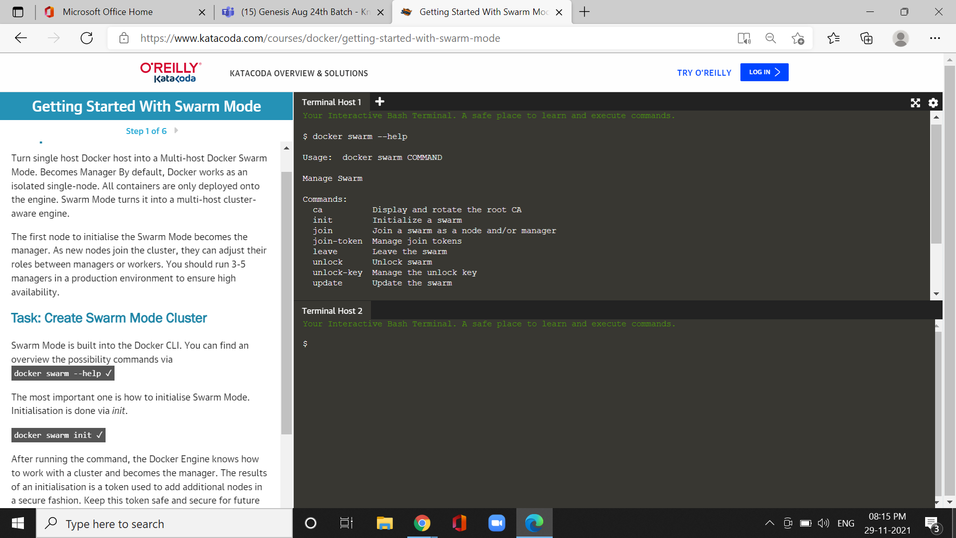

cmd:token-$(ssh -0 StrickHostkeyChecking=no 172.17.0.66

“Docker swarm join-token -q worker”) && echo $token

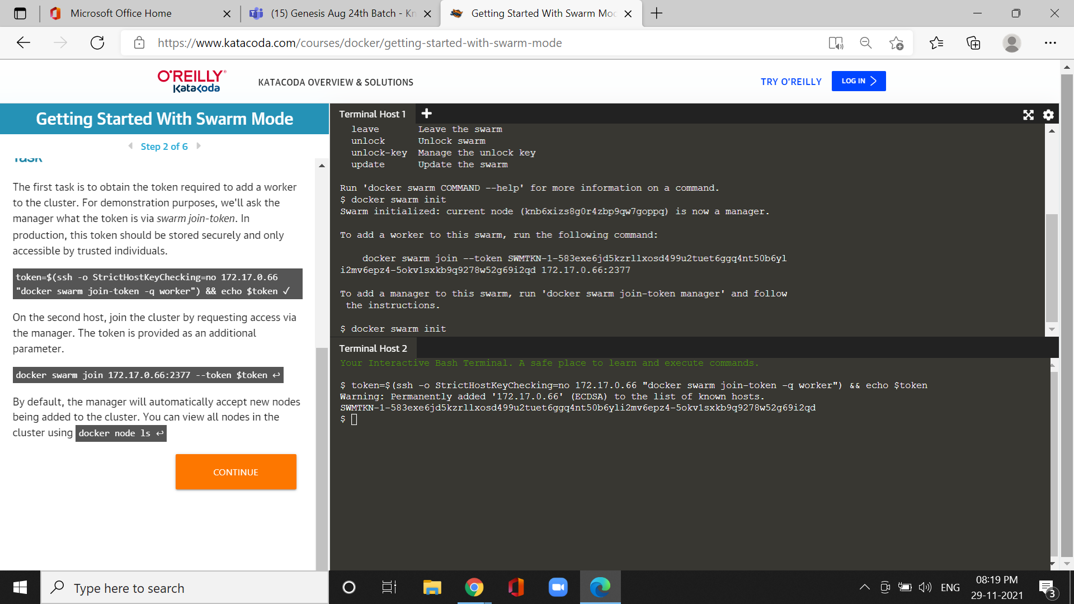

Cmd :docker node ls

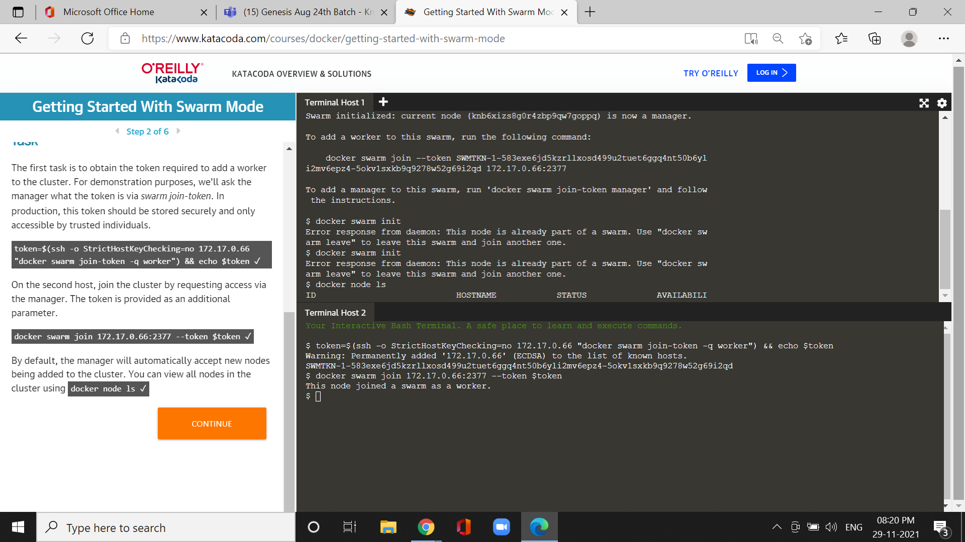

* Virtual Extensible LAN (VXLAN), designed for large scale cloud based deployments.

Cmd:docker network created -d overlay skynet

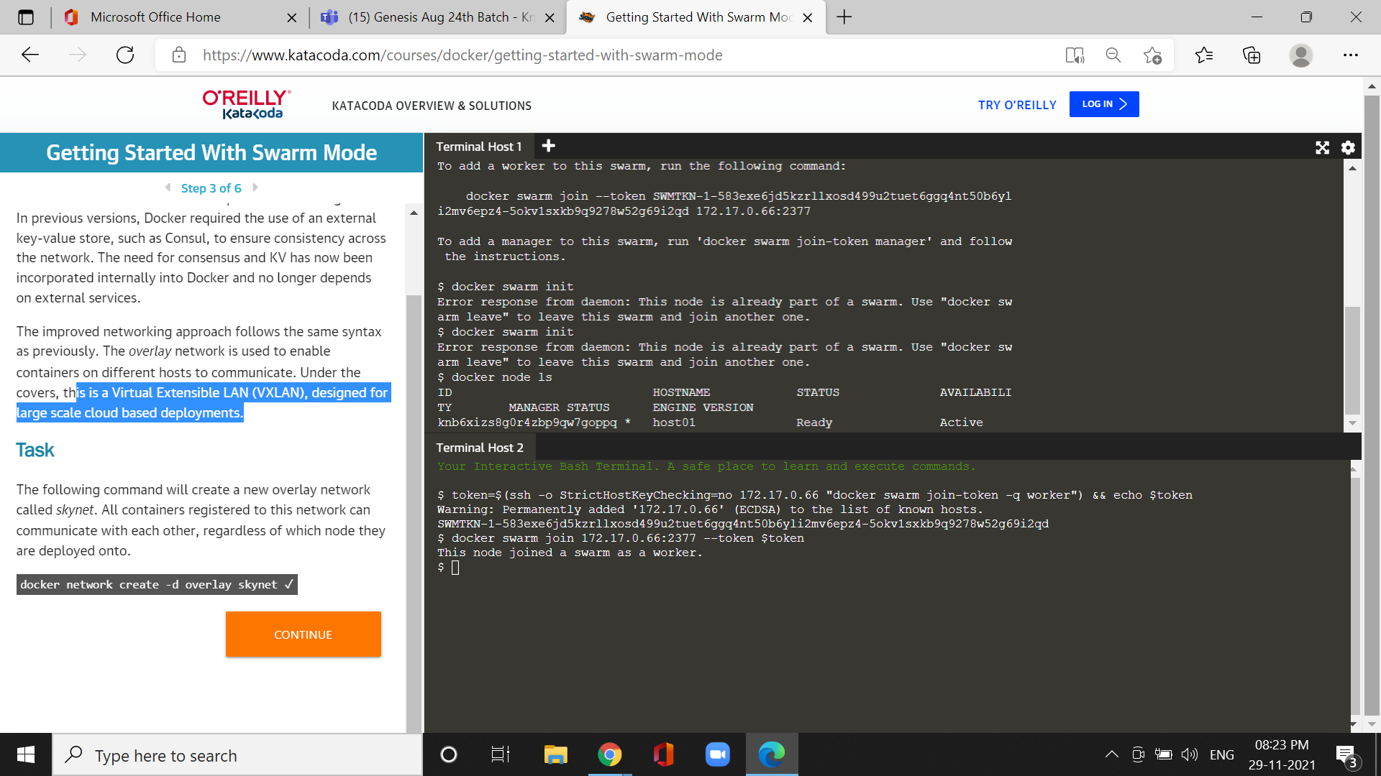

Cmd:docker service crestae --name https --network skynet -- r

Replicas 2 -p 80:80 Katacoda/docker-http-server

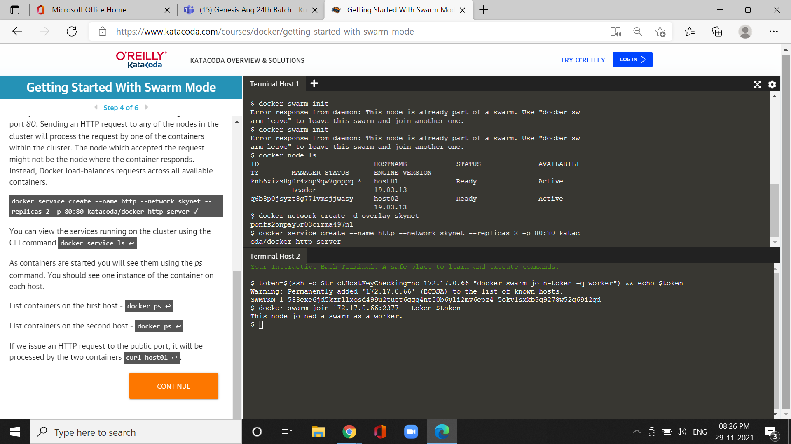

Cmd :docker ps

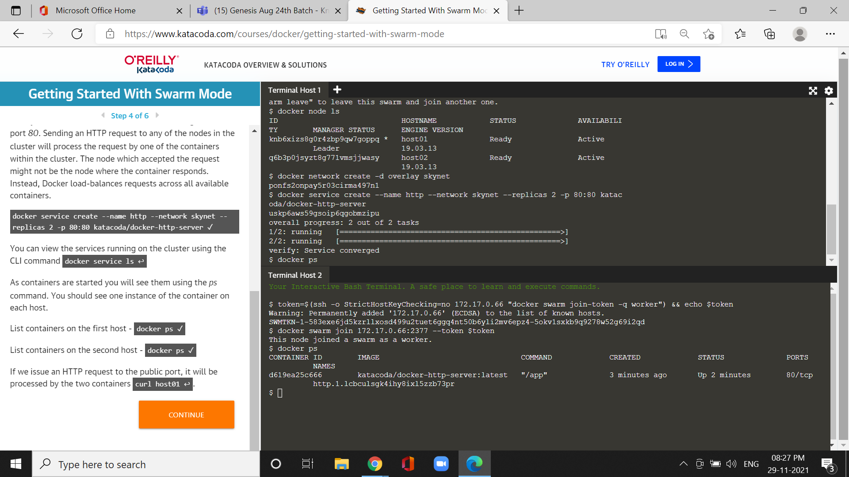

Cmd:docker service ps http

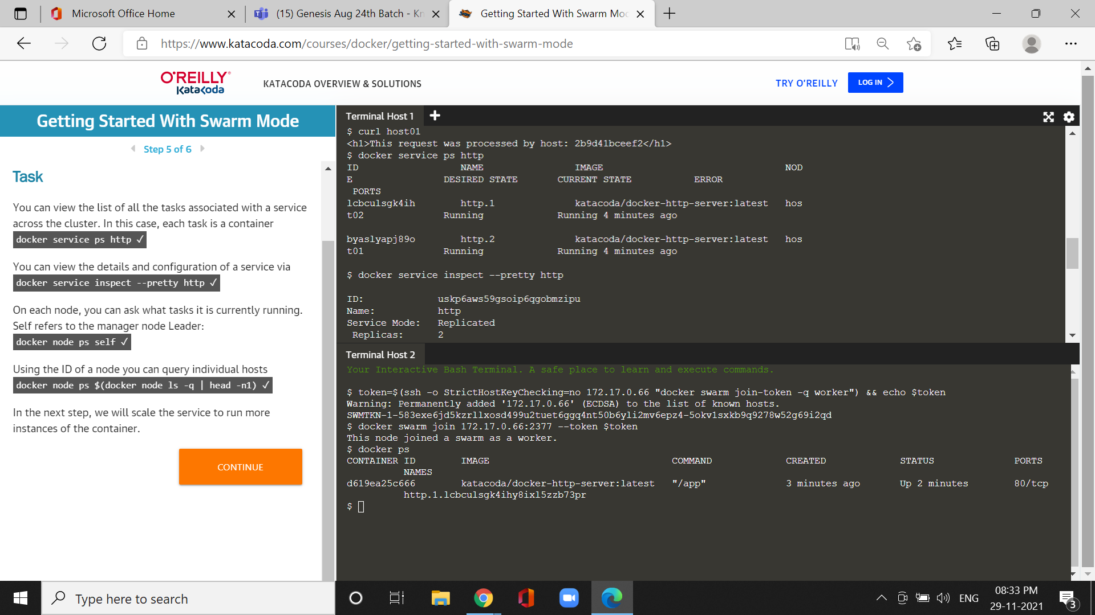

Cmd docker node ps $(docker node ls -q |head -n1)



Cmd :docker service scale http=5

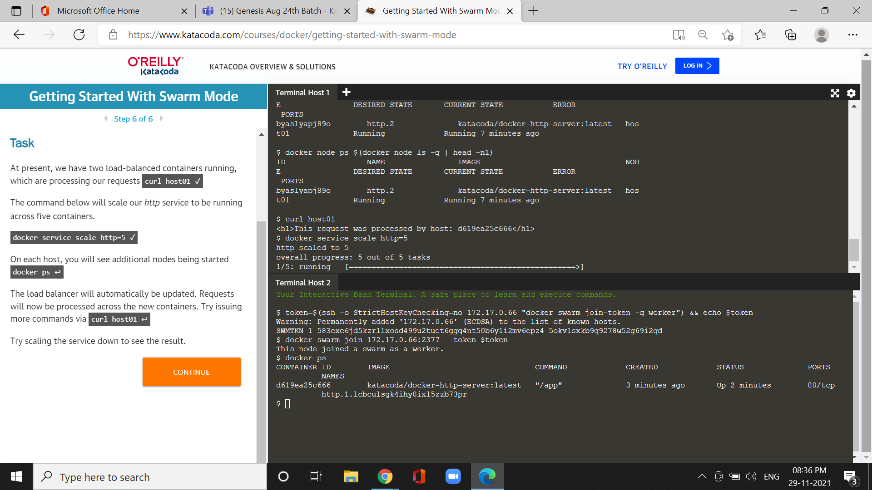

Cmd: docker ps

